- Monetary Policy Committee members Andrew Bailey and Megan Greene laid out different perspectives on the outlook for UK inflation and interest rates. We side with Bailey in forecasting that inflation will cool and provide room for more rate cuts during 2026. But it's becoming increasingly clear that the MPC will take a more cautious approach than they have so far.
- In a quiet week of data, the S&P Global and CBI surveys suggested the underlying pace of activity growth remains sluggish. There remains a significant divergence between the expanding services sector and struggling manufacturing, with recent supply chain disruption in the automotive sector adding to the problems faced by manufacturers.
After last week's Monetary Policy Committee meeting and bumper crop of Office for National Statistics releases, this week has been a time for reflection and allowing the dust to settle.
The only data came from the CBI and S&P Global surveys for September, and these yielded mixed results. The flash S&P Global survey reported a sharp drop in the composite PMI to 51.0, from 53.5 in August. But August's outturn had been an outlier, and the September balance was in line with the average over the year to date (Chart 1). As ever, the news flow likely explains some of the month-to-month volatility, with the announcement of US trade deals in August being followed by gloomier domestic news in September, as London endured tube strikes and the inevitability of tax rises in the Budget became increasingly clear.
The S&P Global survey reported a much steeper fall in manufacturing output than in August, with respondents reporting a marked impact on the automotive supply chain from plant stoppages. But there was slightly better news from the CBI's Industrial Trends Survey, which reported an easing in the pace of output declines this month. Meanwhile, the CBI's Distributive Trades Survey suggested that retail sales continued to fall at a rapid pace over the year to September, extending the run of negative balances to a year.
Chart 1: The composite PMI has been very volatile this year, but has largely signalled sluggish growth
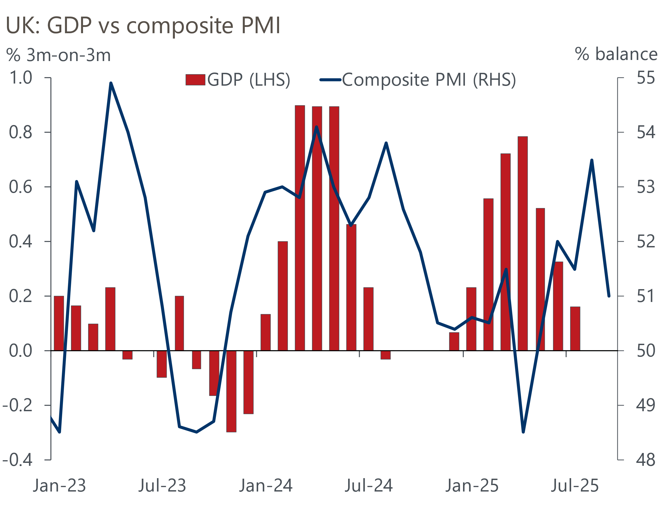
Sources: ONS, S&P Global

The read-across from the surveys to official data has been poor, partly reflecting data quality problems on both sides. But the big picture remains one of sluggish activity growth across the economy as a whole, with the services sector holding up better than manufacturing.
On prices, the surveys largely told a story of inflationary pressures easing in the manufacturing sector, as intense competitive pressures bore down on margins. But the S&P Global survey reported that the rate of services sector inflation remained strong, with September's balance only just below the average over the year-to-date. This stickiness in price pressures has become an increasing concern for the MPC in recent months and is one of the reasons why we expect the committee to break its cut-hold pattern and keep Bank Rate at 4% in November.
Bank of England Governor Andrew Bailey gave the impression that this was a likely outcome in an interview with West Mids Life as part of his regional visit to Wolverhampton this week. Bailey said he thought there was further to go on rate cuts but echoed recent BoE messaging in highlighting the balance between persistently high inflation and a softening labour market.
Bailey said interest rates could fall further because policy is currently "restrictive". The degree of restrictiveness was also a core theme of external MPC member Megan Greene's speech to the University of Glasgow Business School. Greene argued that recent supply shocks – the pandemic and war in Ukraine – had shifted the risks to the inflation outlook to the upside. She claimed the weakness of productivity growth and decline in the 16+ employment rate since the pandemic were evidence of a structural shift in the supply side of the economy. Greene was also concerned that, as disinflation has been concentrated in interest rate-sensitive sectors, the bulk of disinflationary pressures may already have come through.
Greene drew two conclusions for policy. First, that there's a need to take a risk management approach to guard against inflation. And second, given that inflation has exceeded the target for a prolonged period, there was a need for monetary policymakers to try to offset supply shocks, contrary to popular wisdom.
That Greene should be more hawkish than Bailey was not a surprise given their voting records over the past year. But the strength of Greene's message, particularly in arguing that the bulk of disinflation may already have happened, was surprising. It certainly suggests she won't support rate cuts anytime soon.
For now, Greene's seems to be a minority view among the MPC, with Bailey closer to the consensus. We think the MPC is underestimating the extent to which the increase in employers' national insurance contributions has boosted inflation this year and expect services inflation to drop as this impact fades. With fiscal policy set to be tightened in the Budget and GDP growth likely to disappoint the MPC's expectations, we expect rate cuts to resume in the new year. But given even those in the middle ground remain very uncertain about inflation prospects, the MPC looks set to cut at a slower pace than it has to date (Chart 2).
Chart 2: We expect the MPC to take a cautious approach to rate cuts in 2026
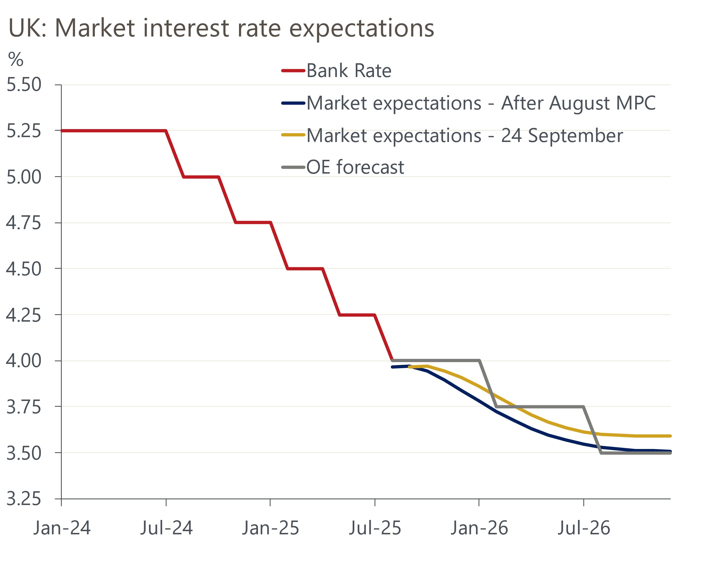
Sources: Oxford Economics, Haver Analytics

The week ahead
Housing market activity has been gradually strengthening as the distortions caused by the end of the temporary increase in stamp duty thresholds fade. We expect August's data to have continued that pattern, although month-on-month increases in approvals should now start to slow. We expect mortgage approvals to come in at around 65,600 in August. Net secured lending is forecast to pick up to £4.8bn, as gross lending likely rose in response to the earlier recovery in approvals.
July's pickup in net unsecured lending was entirely due to a sharp fall in repayments. We expect repayments to rebound in August, and with gross lending likely to remain sluggish, we forecast net consumer credit will drop to £1.1bn.
The Quarterly National Accounts for Q2 will incorporate the annual Blue Book revisions, as well as rebasing the data to 2023 prices from 2022 prices. We already know that the new data will tell us that GDP growth was marginally higher between 1997 and 2023. But there's a good chance that GDP growth in H1 2025 will be revised down, with the Office for National Statistics set to incorporate the recent corrections to the seasonal adjustment of retail sales.
September's flash S&P Global survey reported a sharp drop in the composite PMI due to a weaker outturn for the services sector. Final readings can be prone to large revisions, and given September's slump was likely sentiment-driven, this one could see a bigger revision than most.
Table 1: Week ahead calendar
Date | Events | Period | Measure | Unit | Previous | Forecast
Sep 29 | Mortgage approvals | Aug | Level | 000s | 65.4 | 65.6
Sep 29 | Mortgage lending | Aug | Net lending | £bn | 4.5 | 4.8
Sep 29 | Consumer credit | Aug | Net lending | £bn | 1.6 | 1.1
Sep 30 | GDP | Q2 | q/q | % | 0.3 | 0.3
Sep 30 | GDP | Q2 | y/y | % | 1.2 | 1.2
Oct 1 | S&P Global manufacturing | Sep | PMI | % bal | 46.2 | 46.2
Oct 3 | S&P Global services | Sep | PMI | % bal | 51.9 | 51.9
Oct 3 | S&P Global composite | Sep | PMI | % bal | 51.0 | 51.0
Source: Oxford Economics

Key forecasts
Table 2: UK forecast overview
(Annual percentage changes unless specified)
 | 2023 | 2024 | 2025 | 2026 | 2027 | 2028
GDP | 0.4 | 1.1 | 1.3 | 0.9 | 1.3 | 1.7
Private consumption | 0.5 | 0.6 | 1.0 | 1.0 | 1.2 | 1.7
Fixed investment | 0.3 | 1.5 | 1.9 | 1.0 | 1.6 | 2.0
Government consumption | 1.6 | 3.0 | 1.8 | 1.8 | 1.6 | 1.7
Exports of goods and services | -0.4 | -1.2 | 2.9 | 0.8 | 1.2 | 1.4
Imports of goods and services | -1.2 | 2.7 | 4.5 | -0.4 | 1.1 | 1.4
Industrial production | -0.8 | -1.2 | 0.3 | -0.3 | 0.8 | 1.2
Consumer prices | 7.3 | 2.5 | 3.5 | 2.9 | 2.5 | 2.1
Unemployment rate (%) | 4.1 | 4.3 | 4.7 | 4.9 | 4.8 | 4.4
Current a/c balance (% of GDP) | -3.5 | -2.7 | -3.3 | -3.0 | -2.8 | -2.7
Government balance (% of GDP) | 5.2 | 5.1 | 4.5 | 3.6 | 2.9 | 2.6
Central bank policy rate (%, EOP) | 5.25 | 4.75 | 4.00 | 3.50 | 3.00 | 2.75
10yr govt. bond yield (%, EOP) | 3.54 | 4.57 | 4.70 | 4.25 | 3.77 | 3.47
Exchange rate (US$ per £, EOP) | 1.27 | 1.25 | 1.33 | 1.34 | 1.34 | 1.34
Exchange rate (euro per £, EOP) | 1.15 | 1.21 | 1.15 | 1.15 | 1.15 | 1.15
Source: Oxford Economics
Table 3: Quarterly forecasts for the UK
 | 2025 |  |  |  | 2026
 | Q1 | Q2 | Q3 | Q4 | Q1 | Q2 | Q3 | Q4
GDP (% year) | 1.3 | 1.2 | 1.3 | 1.4 | 0.9 | 0.8 | 0.9 | 1.0
CPI inflation (% year) | 2.8 | 3.5 | 3.9 | 3.8 | 3.5 | 2.7 | 2.7 | 2.6
Bank Rate (%, EOP) | 4.50 | 4.25 | 4.00 | 4.00 | 3.75 | 3.75 | 3.50 | 3.50
10yr gilt yield (%, EOP) | 4.70 | 4.48 | 4.75 | 4.70 | 4.66 | 4.54 | 4.40 | 4.25
US$ per £ (EOP) | 1.29 | 1.37 | 1.33 | 1.33 | 1.33 | 1.33 | 1.34 | 1.34
Euro per £ (EOP) | 1.20 | 1.17 | 1.15 | 1.15 | 1.15 | 1.15 | 1.15 | 1.15
Source: Oxford Economics

Latest Country Economic Forecast:
September 16, 2025

Recent publications

Data Insights
PMI confirms sluggish growth outlook
Borrowing points to difficult fiscal decisions on the horizon
Retail sales climbed further in August, but the outlook isn't as rosy
Inflation remained stable in August
Labour market shows little sign of generating disinflation

Research Briefings
Fiscal fragility could reveal sterling's vulnerability
MPC follows path of least resistance on quantitative tightening
MPC preview – Pace and shape of QT is likely to be tweaked
What could prompt the BoE to cut further and/or faster?
Stagflation-lite as policy headwinds increase turbulence

Contacts

Oxford Economics' UK team
- Andrew Goodwin - Chief UK Economist - agoodwin@oxfordeconomics.com
- Edward Allenby - UK Economist - eallenby@oxfordeconomics.com

